GÓBÉFEST
2024

Trader Information Pack

Event Management:

Ottilia Ördög 07812 107134

Paul Gardner 07812605333

SECURITY Manchester Security

Market Coodinators:

Required Documents

Insurance
- Public Liability Insurance – All traders are required to carry a minimum £5m Public Liability Insurance.

Insurance - Manchester City Council strongly recommend that all participants at the Góbéfest obtain comprehensive travel insurance to cover themselves and stock whilst travelling to Manchester.

We strongly advise you to obtain adequate insurance to cover all potential eventualities including the unavoidable curtailment of the festival/market, fire, theft, or vandalism/damage to your house / stock.

Traders Risk Assessments
All traders are required to complete a Risk Assessment for the erection and dismantling of gazebos (where applicable), house fit-out and your day-to-day market operation.

If you have your own additional contractors on site, such as electricians, carpenters, builders etc you are required/responsible for obtaining and evaluating their Risk Assessments, Manchester Markets will require a copy to be included with your Risk Assessment.

Catering Stall Management Plan
All traders selling and/or preparing food or drink for consumption on site must complete and return a copy of the ‘Catering Stall Management Plan’. A copy of allergen information for anything you serve or sell must be included and displayed. If you sell items advertising Nutella, please note that you cannot use any other brand without informing your customers as Nutella is safe for some people with nut allergies, but other brands are not. This could be deadly for people with severe allergies.

A copy of this document must be submitted to the Góbéfest management prior to trading. A copy of this document must also be kept on your stalls at all times. If you require further information regarding the Catering Stall Management plan, then please contact the Góbéfest directly.

Environmental & Sustainable Festival Markets

Góbéfest makes every effort to reduce the environmental impact of the festival and the festival market and promotes sustainability. Some of the initiatives we employ are:
- Reusable mugs and glasses for all drinks at the festival.
- Food containers and cutlery are recyclable
- Investment in low energy light bulbs across the market
- Food traders, where possible, encouraged to source locally produced produce and locally produced soft drinks.
- NO SINGLE USE PLASTICS TO BE USED ON THIS MARKET (Including cutlery, taster glasses and carrier bags)

We ask that traders help the market to maintain its green credentials, some ways you can participate in this are:
- Turn off all lights and equipment when not in use.
- Use the recycling collection bins provided.
- Reduce use of wrapping and bags wherever possible.
- Offer your unwanted packaging to other traders, who may be able to use it.
- Source products locally.
- Cardboard and paper - separate, squash down and neatly stack all cardboard inside the allocated recycling container. Do not put other refuse into this container.
- Glass and Plastic bottles – remove lids and place in bins, lids go in general waste.
- Tin cans –wash and place in bins.

Recycling – Paper, Glass, Plastic, Tin Cans
Recycling – Cardboard, Refuse, and Food Waste

Co-mingled waste –
Traders are required to keep their stalls and surrounding area clean and tidy; this includes sweeping and litter picking the area directly outside your stall throughout the day and each evening.

Do not leave boxes or other refuse out for collection, or place bags on the street or around the litterbins. They will not be collected and will be regarded as street littering which may incur an instant penalty fine. Góbéfest is powerless to intervene if a Penalty Fine is issued.

Emergency Procedures

For your own safety and the safety of your staff, it is the responsibility of each trader to ensure that your staff are fully trained and aware of Góbéfest Emergency Procedures. Góbéfest will monitor this throughout the festival, if it is found that any member of your staff is not aware of the procedures, traders will be required to close their stall until the appropriate training has been delivered.

Fire Emergency - Procedures for Traders
On discovering a fire
- Evacuate all staff and customers from the stall and the vicinity of the fire. Phone for the emergency services - 999.
- Raise the Alarm - Inform the nearest Security guard or Góbéfest Management personnel.
- Only tackle a fire if you are trained on equipment use and it is safe to do so.
- If safe to do so, turn off any gas appliances.

Traders and Staff – On being informed of a fire
- Stop serving immediately, inform customers of the fire and the need for them to evacuate the stall and area
- Turn off any gas source.
- Leave the stall by the nearest exit. If it is safe to do so, close the shutters to the stall
- Do not attempt to take personal possessions with you.
- On the way out of the area, inform customers that an evacuation is in process and advise them to leave the area by the quickest safe exit.
- Report and remain at the Fire Assembly Point.
- Do NOT attempt to return to your stall

Traders are responsible for members of their staff and assistants working on a stall.
- You must train your staff to know what to do in the event of an emergency and keep a record of the training.
- Account for all your staff and report this to Góbéfest Managemene, Emergency Services at the Fire Assembly Point.

Góbéfest staff, traders and Security will only be allowed back on site when it has been authorised as safe to do so by the Emergency Services.

Fire Precautions on Stalls
If using any equipment in your stall, other than additional low voltage lighting, you must supply adequate numbers of Dry Powder Fire Extinguishers. You will not be permitted to open your stall if this emergency equipment is not present.

Fire Extinguishers – ABC40 Dry Powder
All catering and drinks traders must supply a minimum of 1 Dry Powder Fire Extinguisher and 1 fire blanket, or equivalent, for each 6m house/pitch of operation and pro-rata for larger houses/pitches.

First Aid Equipment
All food and drink traders must supply and maintain an appropriately stocked first aid box.

Electricity

Safety
All electrical equipment over 12 months old is required to be PAT tested. Electrical contractors on behalf of Góbéfest Management will check all equipment on your stall. Any items not in compliance with the following will be removed from your stall:
- Display a current green Electrical Safety Test PASS sticker. OR
- If electrical items are less than 12 months old receipt of purchase must be held on the stall for inspection when required.

The use of kettles, microwaves, or halogen lighting is strictly forbidden.

Electric Supply
Craft and Gift Stalls will receive a maximum power supply of 5amps if requested – this is inclusive of the internal and external lighting on the house. 5amps is an ample supply for the use of additional low energy lighting and most tills or weighing equipment.

The use of high energy equipment such as heaters and kettles will cause the power in your stall, and potentially the stalls of other traders, to fail. When notified of a power failure, Góbéfest staff will endeavour to rectify the problem as soon as possible.

Any trader identified as over-loading the power supply may be refused the opportunity to trade at future festivals in Manchester.

Traders, their staff and members of the public MUST NOT tamper with electrics. If you are experiencing problems with your electric supply, please contact a member of Góbéfest staff as soon as possible.

Electric Management

The markets are to be supervised permanently by a BS7909 electrical engineer. The engineer will be contactable via the Góbéfest management team.

Before any power supplies are provided to larger stalls, sufficient & relevant UK certification (in accordance with BS7671 or BS7909) must be provided to the engineer. Without this certification, no power will be provided.

For smaller stalls, the BS7909 electrical engineer will establish all appliances are PAT tested before power is provided. If appliances are not tested, you will be requested to remove them or no power will be provided to the stall.

The BS7909 engineer will monitor portable appliance testing during the event. Access must be made available for stall inspections, non-compliance with this may lead to the disconnection of the electrical power supply.

Gas

To comply with Gas Safety recommendations, we will require traders using gas at Góbéfest to implement the following requirements:

Gas Boxes - All gas bottles must be stored in an appropriate metal box
- Boxes should be thick, heavy gauged galvanised steel.
- Boxes must be appropriately ventilated to allow air circulation and gas diversion – vents at top and bottom of the box.
- These metal boxes must create a barrier between the gas bottles and any flammable material i.e. wood / paper/ plastic.
- Prior agreement from Góbéfest management is required to site gas bottle boxes outside of a stall. This must be accessible from outside and contained within a wooden clad gas cage.
- The use of rubber flex pipes is strictly forbidden.
- All gas installations will be required to be inspected and signed off prior to trading.

Flame Supervision Device (Thermal couple device)
All appliances must be fitted with a Flame Supervision Device

Isolator switches (cut off tap) must be fitted:
(a) at bottles after regulator.
(b) be fitted before appliance/s

Leak Detector Spray on-site
You must hold an appropriate level of leak detector spray on site and ensure bottles are checked every time they are changed.

Gas Management

An induction is to be provided to all store occupiers for the safe changeover of gas containers (bottles). Each stall shall nominate a competent person to receive this training. No other personnel are to undertake changeovers.

** No gas is to be used on site without a valid GAS PERMIT in place **

Each stall is to be inspected by a Mechanical engineer prior to receiving a permit to use gas.
The mechanical engineer will need the following before a permit can be issued:

(a) Gas Safe Commissioning certificate – to be displayed within the stall in visible location / wall.
(b) Copy of Induction certificate for safe changeover of gas bottles.
(c) Access for a visual inspection of stall gas installation.
(d) Evidence of leak detector spray on site.

The permit is to be displayed within the stall in visible location / wall and is valid for the duration of the event. Stalls which do not have the relevant certification and permits will be asked to stop using gas with immediate effect.

Mechanical engineers will undertake random checks to ensure safe working practises are maintained, access must be available for inspection.

Look & Feel

Góbéfest Gazebos

Traders are required to return gazebos in the same state of cleanliness and repair as they find them.

Please do not make any alterations or permanent adjustments to the gazebos. You will be liable for any damage you or your agents cause to the stall

In very heavy rainfall, water may seep through the gazebo, it is suggested that you move items of stock away from the walls overnight and when it rains.

Stall Repairs
If gazebos are damaged or vandalised, we will endeavour to facilitate repairs as soon as possible, however, we do not have a maintenance team on full-time call out.

Stall Display
Each individual stall display helps to create the overall impression of Góbéfest to the customers; therefore, it is important that each stall display is of a suitable standard.

All stall displays and decoration must be pre-approved by Góbéfest. Please contact Góbéfest Manager via email to discuss your ideas.

To add to the atmosphere of Góbéfest stalls should be dressed in decorations preferably of a type that is traditional to your country of origin.

Tinsel and rope lights are not permitted on the market.

Signage

Traders are required to provide a sign stating their trading name. The sign must be of a professionally produced high standard, fitting for this prestigious event. The use of home-computer generated laminated signs will be judged by Góbéfest on an individual basis, but generally are not considered of a fitting quality for this festival.

No signs are permitted on the roof. All signs must be attached at a minimum of 4 points. Góbéfest will remove any sign they feel is unsafe.

Signs on the front of the stall must be no more than 1000mm wide x 500mm high.

Banner signage is not permitted for use on Góbéfest. All signage must be pre-approved for use by festival manager (details above).

Product Labelling

Product labelling must be of a high standard befitting Góbéfest.
The use of day-glow signs or day-glow price labels is strictly prohibited.

Quality Assurance

One of the reasons Góbéfest continually succeeds is due to the quality of the market offer. To maintain the quality level of the market we undertake individual traders Quality Assessments (QA’s). This assessment will check you have all the mandatory equipment and/or signage required for your stall, it will also evaluate the quality of your products, to ensure they match the details provided on your application form, and you product display and customer service.

If we have any concerns, we will issue an improvement notice that must be implemented as soon as possible and within the timescale stipulated. We will be happy to work with any trader to bring your stalls up to the standard required for this prestigious event. Failure to act on an improvement notice may result in the issuing of a warning letter. Receipt of a warning may affect a trader’s invitation to return to trade at Góbéfest.

Food and Drink Traders

Personal Appearance
Traders selling food must maintain high levels of personal and working hygiene at all times. Traders selling food should include the wearing of appropriate clothing, including clean full aprons, catering hats, gloves (where appropriate).

Price List
You must display a price list to make sure that the price of food and drink is made clear to the customer. The price list must show:
- The name of the food and drink in English
- The price of the food or drink
- The quantity (where items are sold by quantity you must mark a unit price i.e. per kilogram or per litre).
- The equipment used to weigh, or measure must be approved for use to trade.

Pre-packed Food and Drink

Pre-packed food and drink must be marked with:
- The name of the food.
- A list of ingredients, in descending order, by weight.
- A 'use by', 'best before' or 'best before end' date.
- The name and address of the manufacturer, packer or seller based in the EEC.
- Place of origin.
- Special storage conditions and instructions for use (if necessary).
These details must be in English.

Non Pre-packed Food and Drink

Non pre-packed food and drink must be marked with:
- The name of the food
- A list of any additives.
These details must be in English.

Allergen Labelling/ ‘Natasha’s Law’

Food traders are required to identify, via suitable signage, all food products that may contain one of the listed allergens which may be harmful to persons with allergies.

For more information check:
https://natashas-law.com
http://www.tradingstandards.gov.uk

Food Presentation and Customer Safety

To protect members of the public from potential harm/injury, any trader selling food (to eat on site or for consumption at home) and/or hot drinks must ensure that a protective barrier is in place to prevent direct contact with sources of heat and/or the food. Góbéfest recommend the use of Perspex screens to assist in the prevention of accidents and to add to the overall presentation of the market.

Protection of the Market Area
Suitable non-slip protective matting must be laid to protect the flooring from grease and prevent slip hazards. Traders must undertake regular cleaning directly outside the front of their stall to protect the street surface from staining and to prevent slip and trip hazards. Please note traders who repeatedly fail to provide suitable floor covering, damage surfaces and/or create slip hazards may be requested to make a payment to cover cleaning costs.

No Glass
Beverages must not be sold in glass containers.

Food Serving Vessels, Cups and Cutlery
All food and drink must be served in containers that are sustainable, preferably re-cycled. (wood/cardboard) Polystyrene and plastic containers are not acceptable/ permitted.

Please note there is a ban on compostable and biodegradable plastic due to come in this year.

Cutlery must be sustainable and preferably re-cycled. Plastic forks and spoons, taster glasses, shot glasses and stirrers are strictly forbidden. (even for soup)

Litter Bins
All food and drink traders must supply 1 litterbin per 6m house. The litterbins must match the look and appearance of your stall and have a lid/roof to contain the litter. These bins are the responsibility of each trader and must be kept clean and emptied regularly.

Traders Selling Alcohol
Traders selling alcohol must comply with the licensing requirement for the sale of alcohol and must cease selling alcohol immediately at the request of a Góbéfest Manager, a Senior Police Officer or a Senior Security Officer.
All traders selling alcohol must display the appropriate signage and keep a daybook detailing refusals of sales on their stall.

All traders selling alcohol, and their managers, are required to attend the Alcohol Safety meeting prior to the opening of the market.

On-Site Consumption
Trading times for the sale of alcohol are: 11.00am to 10.30pm every day.
All traders selling alcohol for consumption on site must possess a bell to be used to indicate last orders and the end of serving.

Last orders: 9.30pm (bell to be rung)
End of serving: 10.00 (bell to be rung) - 15 Minutes drinking-up time
Market / Bar Closure: 10.30pm

All bars must keep a Mug & Glass Collection Point open until 10.30pm to return deposits. The Management will operate checks to ensure that this happens.

Beer, Lager
Must be sold in quantities of ¹/₂ pint or 1 pint.

Wine
You must display a notice to advise customers of the quantity of alcohol you are selling. The quantity must be measured using equipment that has been passed as fit for the trade – optic measure or a thimble measure to measure the drinks. Bottle top pourers are not approved for use in the UK and cannot be used.

Off-Site Consumption
It is the traders’ responsibility to ensure that customers do not consume the alcohol on site. The trading times are 10.00am to 8.00pm each day.

Staff Requirements
If a Trader is to sell alcohol, there must, at all times throughout the trading period, be a person working on the stall who is a minimum 18 years old and hold a BIIAB Level 2 National Certificate for Personal Licence Holder.

Traders must display a scheme of delegation detailing all staff trained and permitted to sell alcohol.

Traders Selling Alcohol MUST COMPLY with the Licensing Act 2003
It is an offence to sell alcohol to anyone under 18 years old. It is therefore a requirement that traders “exercise due diligence” by rigorously adhering to the age-related restrictions and by asking for proof of age from any person about whose age there is a doubt. Documentary evidence of proof of age can be:
- A photo driving licence
- A passport
- A proof of age scheme card that carries a PASS logo. – If the person serving suspects that the proof of age card does not belong to the bearer or has been tampered with, they must refuse service.

Alcohol must not be sold to anyone who acts or appears drunk. Traders are required to keep a written record of all incidences where you refuse the sale of alcohol to any person, this should include: the date, time and reason for refusal. This record must be available for inspection by the licensing authority and Góbéfest officers upon request.

Traders must supply and display appropriate signage in accordance with the Licensing Act 2003. Such as:
- It is an offence to purchase or attempt to purchase alcohol if you are under the age of 18 (Section 149 Licensing Act 2003)
- It is a criminal offence for any person to sell alcohol to a person who is under the age of 18 anywhere. There are no exceptions.

Any trader, or their agent, found to violate, or to have violated the Licensing Act 2003
will have their stall immediately closed and will be removed from the market.

The trader will not be invited to return to trade with Manchester Markets.

Parking

Market Traders Vehicle ID Forms
Included in this pack is your Market Trader’s Vehicle ID form. The vehicle form identifies your vehicle as belonging to a trader at Góbéfest and should only be used when loading and unloading at the festival site. The form is not a parking permit / ticket and will not allow you any special dispensation if you leave your vehicle in a parking restricted area.

You have to complete the details required on the form and display it in the windscreen of your vehicle at all times your vehicle is on the festival site. You may be denied access to site if you do not display the form on the windscreen of your vehicle.

Please note that Manchester City Council keeps records of all vehicle registrations that have been issued with parking fines. Traders who are found to not have paid in full their fines will not be invited back to Manchester to trade at the Christmas Markets.

Random vehicle searches will take place before and during the event for any vehicle parked within the market demise, in line with recommendations from our Counter Terrorism Unit (CTU)

Parking
Parking is not provided for this event; however, the market security or festival Managers will be happy to advise you on parking in the vicinity of the market.

National Car Parks have various parking within the city centre. The details are as follows:

Manchester China Town
Sackville Street
Chorlton Street
Bridgewater Hall
Manchester Central

Full details available at ncp.co.uk

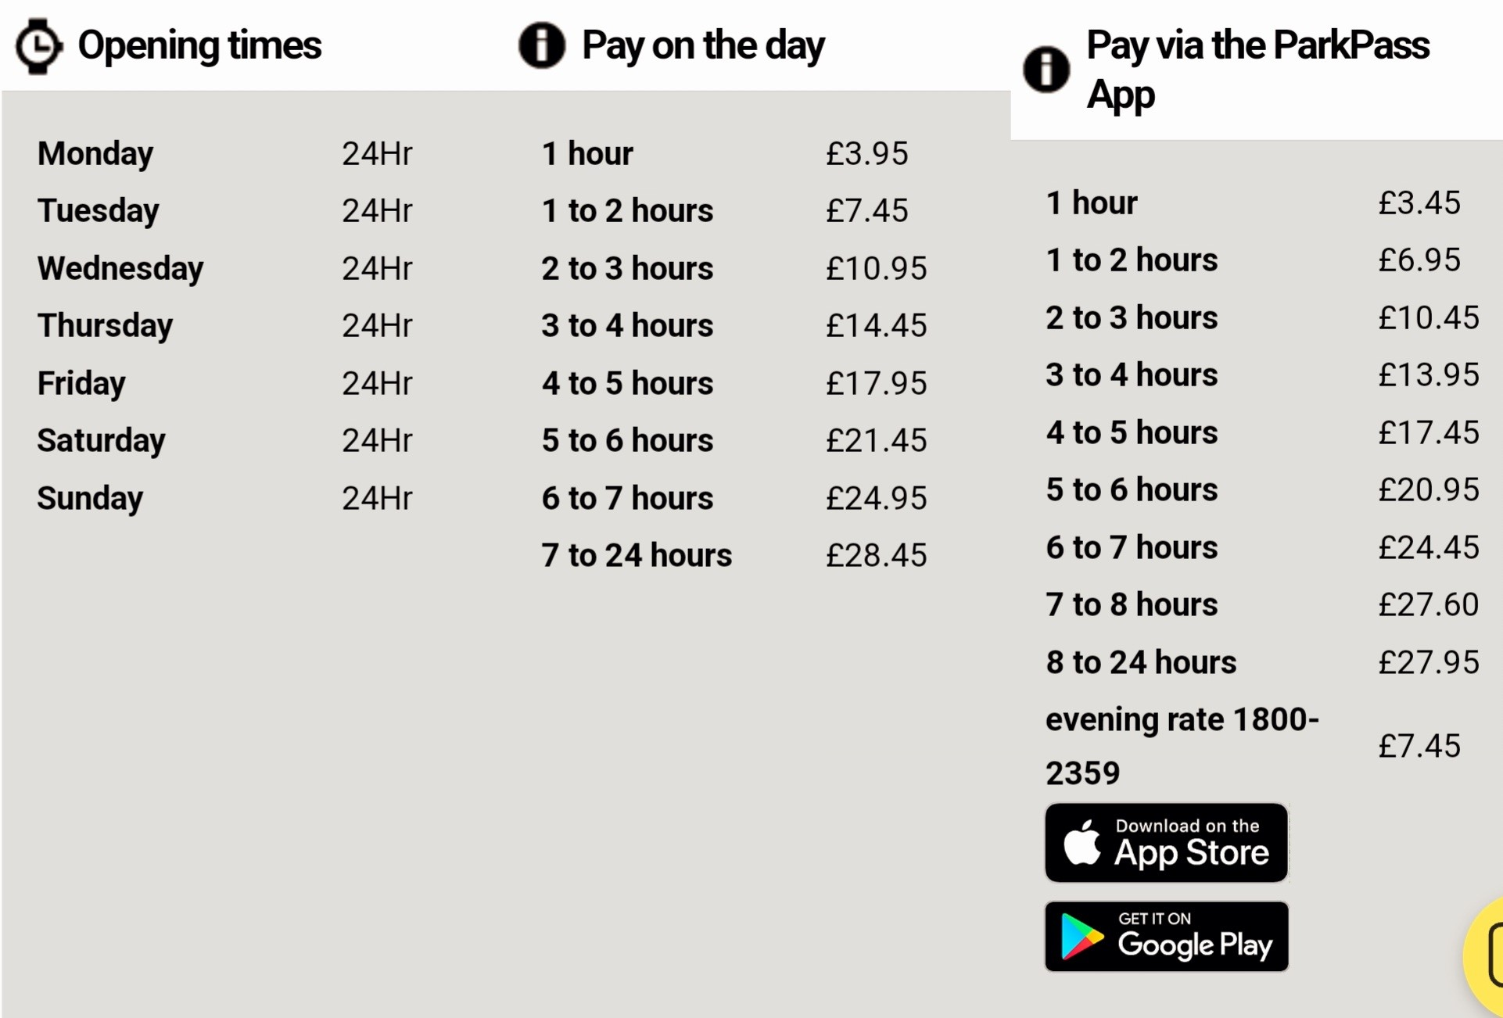

Prices subject to change.

Other Information

No Smoking/ Electronic cigarettes
Traders and their staff are prohibited from smoking/ vaping whilst on the stall or within the vicinity of the market. Traders and their staff must not smoke/vape in areas of the market restricted to the customers (i.e. storage compounds).

Smoking/vaping will not be permitted by customers in your house. Please provide the appropriate signage and procedure to ensure the ban is enforced. Traders will be individually liable for any breach of the law.

Toilets
We have agreements with the Football Museum to offer toilet facilities to festival visitors.

Traders Receipts
Upon request traders must be able to provide a receipt for purchases made at the market. Receipts must include your business name, address, telephone number and if applicable, VAT registration number.

Inland Revenue
On request, Manchester Markets are obliged to supply the details of all traders (including our European guests) attending the markets to the Inland Revenue.

European Traders – your details will be passed to your country of origins’ Tax authority equivalent of the UK’s Inland Revenue

HM Customs and Excise
Importers of excise goods must, upon request by Custom and Excise Officers, produce the relevant documentation for the import of excise goods. For help and advice on this issue please contact HM Customs and Excise directly on 0300 200 3700 – Monday to Friday 8am to 6pm.

Trading Tips
Whilst we hope your time trading at the Góbéfest will be profitable and enjoyable, we urge caution when trading. Please be aware and alert to the potential for theft, especially with regards to any stock and money you may be carrying.

Most thefts at such events are ‘opportunistic’, that is to say someone sees an opportunity to steal something and takes it. We do not believe that trading in Manchester makes you more or less vulnerable than if you were in any other Town or City. However, we want to try and ensure that your time in our city is a happy one, and to this end Góbéfest have some handy hints for you to consider when trading here and elsewhere: -
- Provide a united front – traders look out for each other. If a thief thinks there are many pairs of eyes watching they are less likely to attempt to steal.
- Instead of cash boxes, opt for a bum-bag or money apron. Cash boxes can be taken in seconds and even if you only use them for small change, thieves will be tempted. Cash boxes give the market an “easy touch” reputation. Please urge your fellow traders not to use them.
- When you have a substantial sum, move it to a safe location:
  - Bank it.
  - Have an associate collect the money to take it off site.
  - Move it to a part of the body that’s hard for someone to pickpocket, e.g. down your socks or in your shoes etc.
- Never count your money in public, if a thief sees that you have a large amount of cash, you may become a target.
- Alter your route each day when leaving the market and always carry a mobile phone.
- When loading or unloading - ask someone to watch your stock when you return to your vehicle and close your van door in between loads – visibly stand guard for each other.
- Personal belongings – never leave bags, jackets or packages “on show” at your stall. If you have to bring personal belongings to the market keep them out of sight or better still, leave them in the boot of your vehicle.
- Act as one, look out for each other and advise each other. If you see another trader’s bag or coat unattended, tell them, as thieves are bound to have seen it too.

Useful Telephone Contact Numbers

Góbéfest staff and security will be patrolling the site throughout the day, however, if you have a problem or need to contact the festival Manager, please use the numbers given or ask one of our Security Officers to contact the manager via our radio system.

Manchester Police 101
Greater Manchester Police 0161 872 5050

Manchester Specialist Market Trading Terms and Conditions & Trader Information Pack
Traders must adhere to all trading terms and conditions and the guidance provided in the trader’s information pack. If trading terms are breached, then traders will be sent a warning letter.

Please consider that warning letters are kept on file and receipt of a warning may mean that you are denied future trading opportunities on Góbéfest and other Manchester Specialist Market Events.

If you would like a translation of these conditions in French, Dutch or German please contact our office.

National Minimum Wage
If you are employing workers as part of this year’s Góbéfest you must ensure they are paid at least the minimum wage. This includes foreign nationals who may be working in the UK temporarily.

There are 4 different minimum wage rates, depending upon age:

Under 18 years old | 18 to 20 years old | 21 to 22 years old
£4.81 | £6.83 | £9.18

Underpayment of the minimum wage often results from commonly made errors. These errors include:
Not paying for all the time worked. All the time a worker is carrying out work, or at the disposal of their employer, is counted as working time and should be paid accordingly. This includes time spent travelling in connection with the job, training or any downtime. An example of unpaid working time for Góbéfest might include time spent preparing the stall to open before a worker’s shift starts.
- Making wage deductions for items that relate to the job. Deductions which you make from a worker’s pay, or payments made by a worker to you, for items or expenses that are connected with the job reduce pay for minimum wage purposes. This could include, for example, safety clothing, uniforms, tools or other equipment needed for the job.
- Charging a worker too much for living accommodation. If you provide a worker with living accommodation there is a maximum amount you can charge them, currently £49 a week, before it starts to reduce their pay for minimum wage purposes. Find out more at https://www.gov.uk/national-minimum-wage-accommodation

As an employer it is your responsibility to keep sufficient records to show that you have paid at least the minimum wage. This includes records to show all time actually worked by a worker.
Payment of the National Minimum Wage is actively enforced by HM Revenue & Customs.
An employer’s guide to complying with National Minimum Wage legislation can be found at https://www.gov.uk/government/publications/calculating-the-minimum-wage





Manchester Specialist Markets Booking Conditions
- Definitions
  - “Trader” means named person on the application form responsible for the operation and management of the Stall.
  - “Manchester Markets” means the Manchester Markets Department of the Council of the City of Manchester and “Manchester Markets” includes The Council of the City of Manchester.
  - The headings do not form part of these Conditions and shall not be taken into account in their construction or interpretation.
  - Any reference to a specific statute includes any statutory extension or modification amendment or re-enactment of such statute and any regulations or orders made under such statute and any general reference to “statute” includes any regulations or orders made under such statute.
  - “Stall” means market stall, table, gazebo, house or pitch.
- Applications and Payments
  - All applications must be made on the appropriate festival Market Application Form and must be submitted to festival management
  - Stall charges in respect of successful applications must be made in advance to Gobefest by bank transfer
  - Any cheques (Return to Drawer) returned unpaid to Manchester Markets will incur a minimum £50.00 administration charge.
  - Positioning and allocation of stalls is at the discretion of the Gobefest. The allocation is designed for the overall benefit of the festival and is final.
  - Subletting of stalls is strictly prohibited.
  - Assignment of a stall is strictly prohibited. The benefit of any stall allocated to the Trader is personal to the named trader and is not assignable to any other individual or group or a successor trader to whom the Trader has sold any part or all of its business.
  - Disabled applicants should indicate any particular access/operational requirements on the application form and must confirm those requirements with festival management before attending the market.
- Trader Cancellations
  - If the Trader fails to attend the Market without prior cancellation, or bona fide explanation within 48 hours of the market, this may result in the cancellation of all future bookings without refund.
  - The Trader must make any cancellations in writing.
  - A breach by the Trader of Condition’s 2.5 and/or 2.6, 4.2, 14.4 are also grounds for immediate termination without refund.
  - All deposits and payments are non-refundable.
  - Refunds will only be made under the following circumstances:
    - If the Trader cancels the booking 42 days or more before the market payment (less non-refundable deposits) will be refunded if stall is re-let.
    - If the Trader cancels the booking 41 days or less before the market – no refund will be made.
- Trading Terms and Restrictions on Trade
  - Only the goods, foods or drinks listed on the application form issued to you by Gobefest and as previously approved by Gobefest may be displayed for sale on or from the stall. Any additional/supplementary or substitution products and/or goods must be removed immediately upon request by an authorised officer of Gobefest.
  - The Trader must attend the market throughout the full operating dates and times as detailed on the booking form issued to the Trader.
  - No stall shall be vacated prior to the closing of the market.
  - All display items must be positioned within the stall area and must not obstruct access to the stall or pedestrian walkways.
  - Stalls are reserved until one hour before the opening of the market, after which time stalls that have not been occupied will be re-allocated or removed.
  - No cash is to be left in the Stall overnight and any stock or equipment left in the stall or in proximity to the stall at night is at the Traders own risk. We will have overnight security on site
- Receipts
  - Upon request Traders must provide customers with a receipt for purchase and such receipt must specify the: Trader’s name, address, contact phone no., date market name, location, and goods purchased, including VAT information if applicable.
- No-Smoking Policy
  - Traders and their staff are prohibited from smoking on the stall or within the vicinity of the market.
- Legislation
  - Traders and their agents shall comply with all current and future legislation, notices, orders and byelaws and shall comply with any restrictions, directions and conditions lawfully imposed by any public authority acting under statutory power. The City of Manchester byelaws in respect of Markets may be emailed upon request.
  - Any Traders of second-hand goods must be registered with a local authority.
- Directions
  - Traders must comply with all reasonable directions of the festival management for the management control and conduct of the Market and with all byelaws, rules and regulations as shall from time to time be exhibited at Manchester Markets central office or to which your use of the stall is subject.
- Refuse, Waste and Stall Cleaning
  - The stall must be kept clean and tidy at all times and all waste removed and appropriately disposed of throughout the day.
  - All refuse must be placed in bin bags, the bags sealed and left in any area designated by festival management. The Trader must remove excess refuse.
  - The Trader must maintain the cleanliness of the area directly around the stall. The area must be swept and if required washed at the end of each trading day.
  - The Trader must leave the stall clean and tidy at the end of the market.
  - The use of “Single use plastics” such as straws, food containers, drink stirrers etc. is strictly prohibited. Any trader found to be using any form of “single use plastic” will be asked to remove them immediately and replace them with suitable receptacles.
- FUR
  - Manchester Markets will not permit any real fur products to
be sold on our markets from 2019.
- Vehicles
  - The Trader must unload and remove their vehicles from the market area a minimum of one hour before the opening of the market, and in any event, vehicles must be removed as soon as unloading is complete and before the stall is set up.
  - No vehicle is permitted onto the festival site during trading times.
  - Vehicles must not be parked on the pavements, loading bays or any restricted areas.
  - When provided, vehicles must display the “Traders Vehicle ID” at all times whilst on the market.
- Stands and Displays
  - The Trader must produce a stall display of the highest standard as deemed fitting for a Gobefest event.
  - Packaging, personal belongings and cash boxes on the stall must not be visible to the public.
  - The Trader must display their business name and address and provide details of origin for all products upon request.
  - Signs and price labels must be manufactured to a high standard.
  - The use of day-glow signs or price labels is strictly prohibited.
  - Fixing of any items to street furniture, the stalls or stall canopies in such a way as to cause permanent damage or marks, is strictly prohibited.
- Food and Catering Traders
  - Any Trader providing catering services MUST complete a Markets Catering Management Plan, including a Fire Risk Assessment before accessing the market site. One copy must be supplied to Gobefest and one held on the stall during the trading period of the market.
  - Only good quality wholesome foods should be sold.
  - Traders cooking food on site must provide neat, non-slip floor covering under all the cooking and surrounding area to protect the surface area of the market or stall.
  - All Traders must comply with the Food Safety (General Food Hygiene Regulations 1995) and the provisions of the Food Safety Act 1990.
  - All foods must be stored in suitable, pest resistant, sealed containers.
  - Traders are required to observe high personal and working hygiene standards at all times including the wearing of appropriate clothing e.g. cooking aprons, hats and gloves.
  - Traders must supply adequate means of cleaning cooking utensils and maintaining personal hygiene.
  - Traders using cooking equipment must provide a suitable means of extinguishing a fire: minimum an appropriate fire extinguisher and a fire blanket.
  - Traders must provide First Aid equipment.
  - Traders preparing hot food and/or hot drinks must ensure that a protective barrier is in place to prevent direct customer contact with sources of heat and/or the food. For example by use of Perspex screens to assist in the prevention of accidents and add to the overall presentation of the market.
  - The use of deep fat fryers is strictly prohibited.
- Food Labelling
  - Traders are required to ensure that all packaged food lists all ingredients on the labels, including details on the inclusion of nuts, nut oils or any nut extracts or nut derivatives that may be harmful to persons with allergies.
- Alcohol
  - The Trader applying for a stall to sell alcohol must hold a BIIAB Level 2 National Certificate for Personal Licence.
  - If a Trader is to sell alcohol there must, at all times, be a person working on the stall who is a minimum 18 years old and hold a BIIAB Level 2 National Certificate for Personal Licence Holder.
  - The Trader and their staff must adhere to the provisions of the Licensing Act 2003 including the display of the prescribed signage.
  - Any Trader, or their staff, found in breach of the Licensing Act 2003 may have their Stall closed by an officer of Manchester Markets.
- Electricity
  - If electricity is available (see individual application forms), the requirement of an electricity supply must be requested in advance and the maximum power supply agreed with Gobefest If this is exceeded the Trader must reduce consumption, disconnect or agree with Gobefest to make additional payments for the electricity.
  - The use of halogen lights, kettles, heaters, microwaves, radios or any similar equipment during the market is strictly prohibited.
  - Electricity at these types of events can sometimes be erratic and may cause electric surges or spikes. If the Trader relies on electricity for machinery such as computers or weighing scales then the Trader shall arrange for battery emergency back up and seek advice from a qualified electrician regarding the fitting of circuit breakers or a residual current device.
  - All electrical equipment must be tested for electrical safety and a current green Electrical Safety Test PASS sticker displayed on each item.
  - The Market Manager will check all equipment on site; only items displaying a current green Electrical Safety Test PASS sticker will be permitted for used on the market.
  - Traders must ensure that their equipment is tested and certified annually.
- Gas
  - Traders must adhere to Manchester Markets “Best Practice” with regard to the use of gas bottles & installations. All gas rubber hoses are strictly prohibited in all circumstance. Only gas cages approved by Manchester Markets are to be used. See Manchester Markets “Best Practice” policy document for further information.
  - Traders using Liquid Petroleum Gas bottles must ensure that they are installed and managed by trained and competent personnel.
  - Traders must hold on the stall a copy of their Gas Safe Catering Safety check. All Gas Engineers must be registered with 'Gas Safe' and competent to work on mobile catering equipment
  - All gas appliances must be fitted with a flame supervision device.
  - Location of gas bottles used on Stalls:
16.5.1 Markets in wooden houses, gazebos or A- frame stalls: Gas bottles must be in appropriate metal lockers.
  - Gas bottles storage is not permitted on the market. At any one time, Traders must only keep a day’s requirement of gas bottles on the market.
- Health and Safety
  - All Traders setting-up their own Stall must submit a completed Risk Assessment to Gobefest before accessing the market site.
  - To gain access to a controlled market site, all personnel must wear appropriate protective clothing, including high visibility vests and appropriate footwear.
  - Use of flammable, explosive, or otherwise dangerous materials or equipment is strictly prohibited at the market.
- Liability
  - If the event has to be cancelled, interrupted, or curtailed due to circumstances beyond Gobefest control, Gobefest shall not be liable to make good any loss incurred by any party booked on the market.
  - The Trader is liable for any loss or damages occasioned to the fabric of the Stall, site or any equipment therein or injury to other persons, as a result of their negligence.
  - The Trader is to have in force throughout the duration of the Market a policy of insurance effected with a reputable insurance company or with underwriters at Lloyds covering the Trader against third party risks for a sum of not less than £5,000,000. Proof of the policy must be supplied to Gobefest in advance of the market.
  - Gobefest will not be liable for any loss due to any breakdown of machinery failure of supply of electricity, leakage of water, fire, government restrictions, inclement weather or act of God which may cause the Stall to be temporarily or permanently closed or trading to be interrupted or cancelled.
  - Gobefest will not be liable for any damage to any electric device used by a Trader powered by an electric supply via Gobefest and nor shall Gobefest be liable for any claims relating to or arising from theft, vandalism or damage to any stock or equipment used at or on or in connection with the stall and / or left on the stall overnight, when the market is closed or the stall is unattended.
  - The Trader indemnifies Gobefest, and will keep Gobefest indemnified, against all losses, claims, demands, actions, proceedings, damages, costs or expenses or other liability arising in any way from the right to use the stall and any ancillary / associated rights, any breach of any of these Booking Conditions or the exercise or purported exercise of the right to use the Stall or any ancillary / associated rights.
  - Without prejudice to the generality of the foregoing provisions of this Condition 19, Manchester Markets will not be liable for any losses, claims, demands, actions, proceedings, damages, costs or expenses or other liability incurred by the Trader or Trader’s employees, customers or visitors to the Stall arising out of or as a result of the Coronavirus disease or any other epidemic or pandemic disease including (but without limitation) the effect of or the compliance with any recommended or mandatory measure introduced by the Government or any other competent authority (including Manchester City Council acting in its capacity as local authority) in connection with or intended to prevent or delay of the spread of the Coronavirus disease or any other epidemic or pandemic disease.
- General
  - The distribution of leaflets is not permitted.
  - Gobefest reserves the right to substitute, waive or change, without notice, any details of the market, or booking conditions and procedures.
  - In the event of a breach of any of these conditions,Gobefest reserve the right to cancel the booking and any future bookings from the Trader without notice and without refund of any fees paid.

PPE (Personal Protection Equipment):
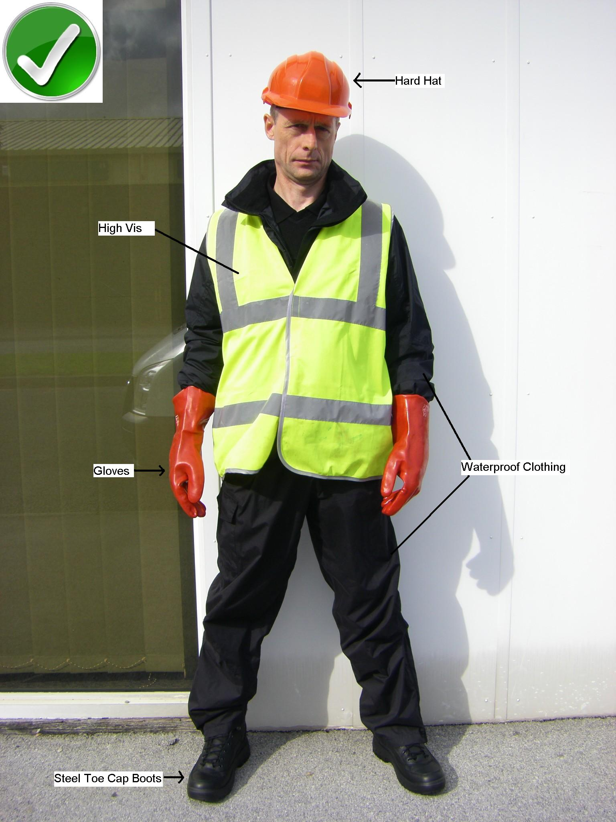 | - Hard Hat  - High Visual Jacket  - Gloves  - Waterproof clothing  - Steel cap boots

Waste Water:
If you need to dispose of water, you MUST use the Water Hut provided.
Do NOT pour anything in the street drains.
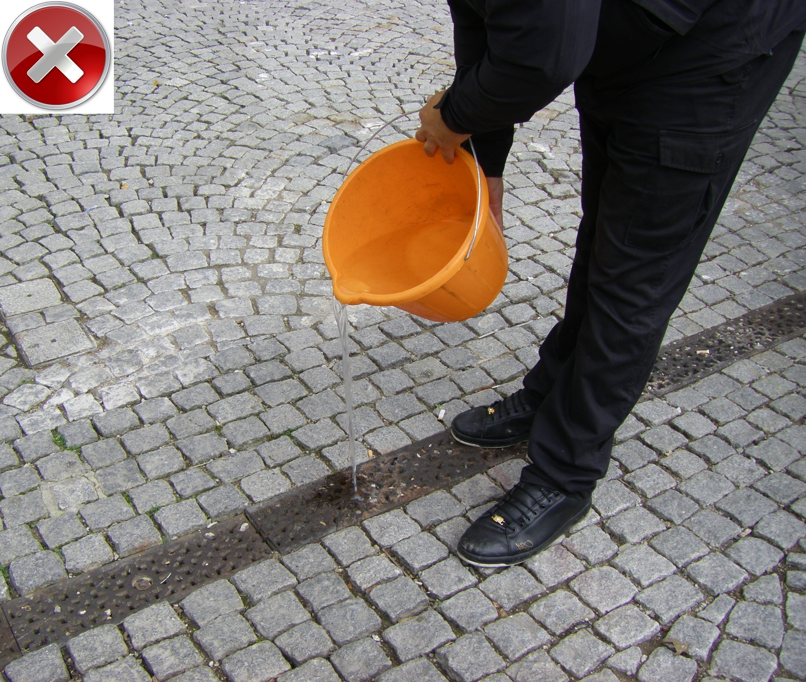 | 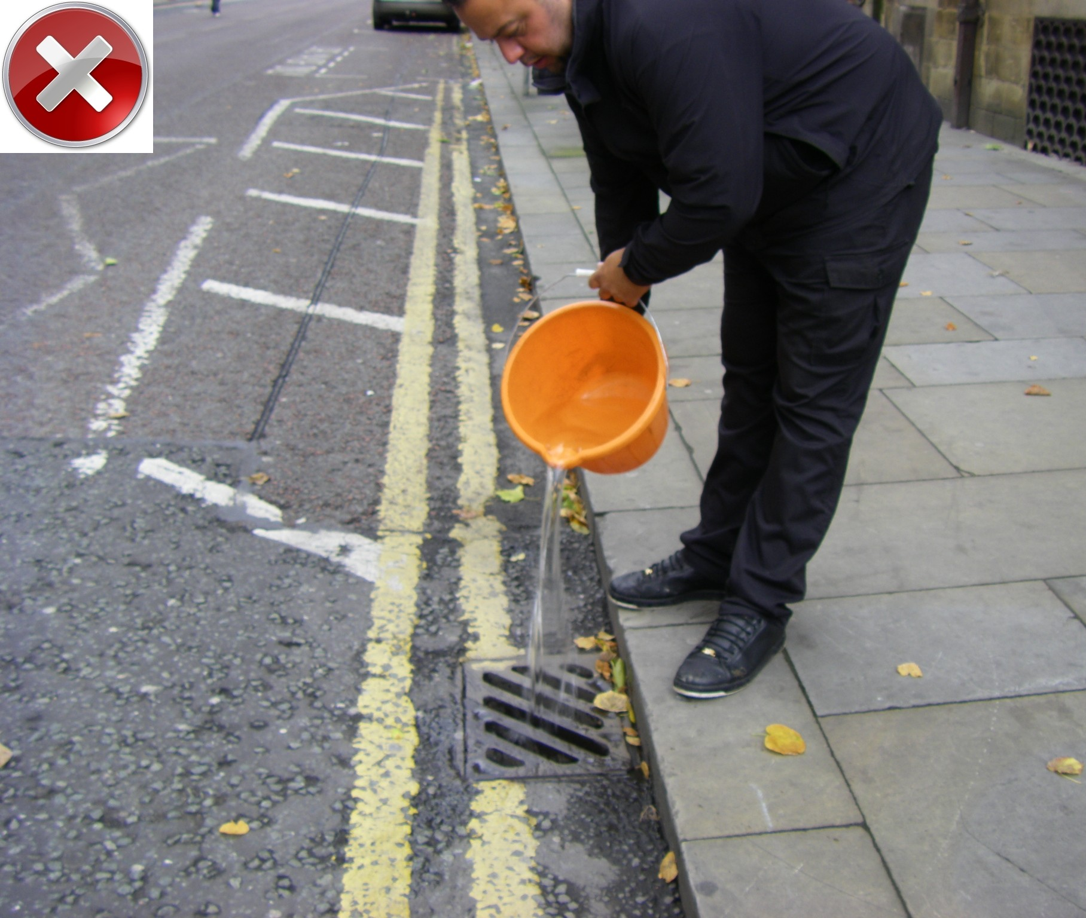 | 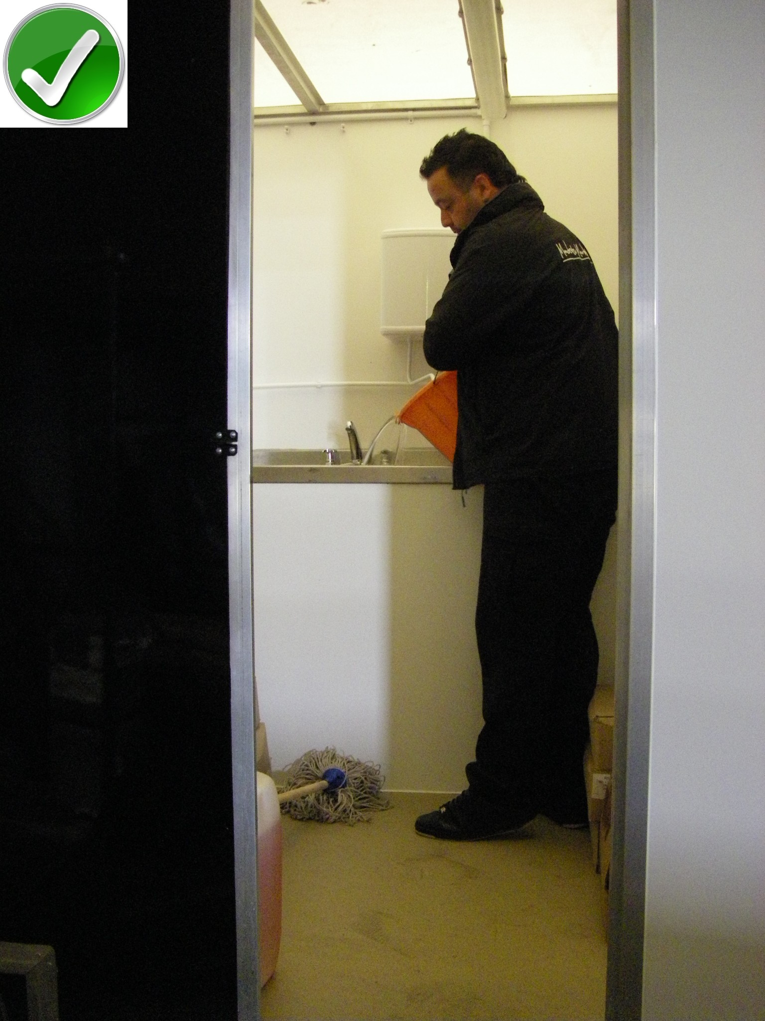

Electrical Equipment:
No Heaters or Kettles allowed. No Halogen lights allowed. No Radios allowed.
All electrical equipment MUST have the PAT test green sticker.
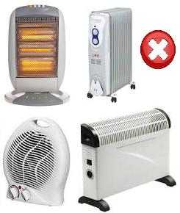 | 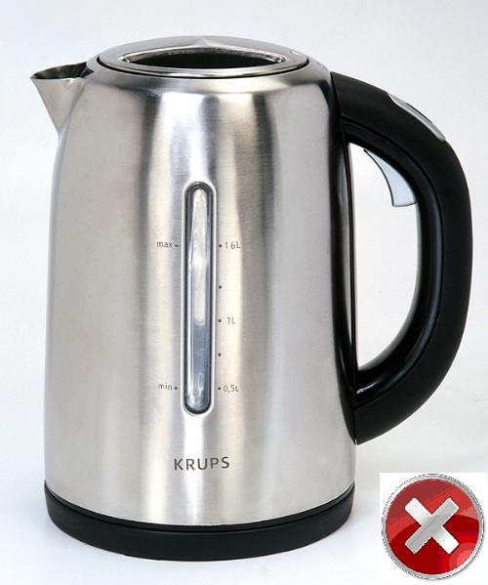 | 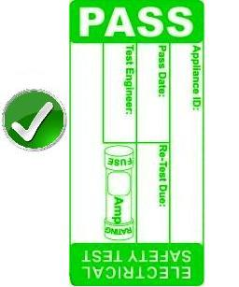

Refuse disposal:
All general refuse MUST be disposed of in closed and tied bags.
Do NOT throw cardboard or glass in the general refuse collection.
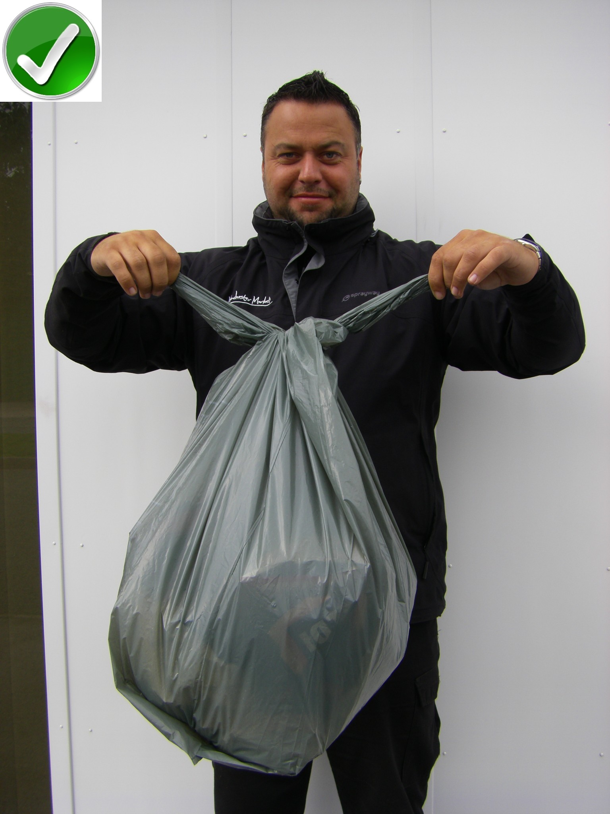 | 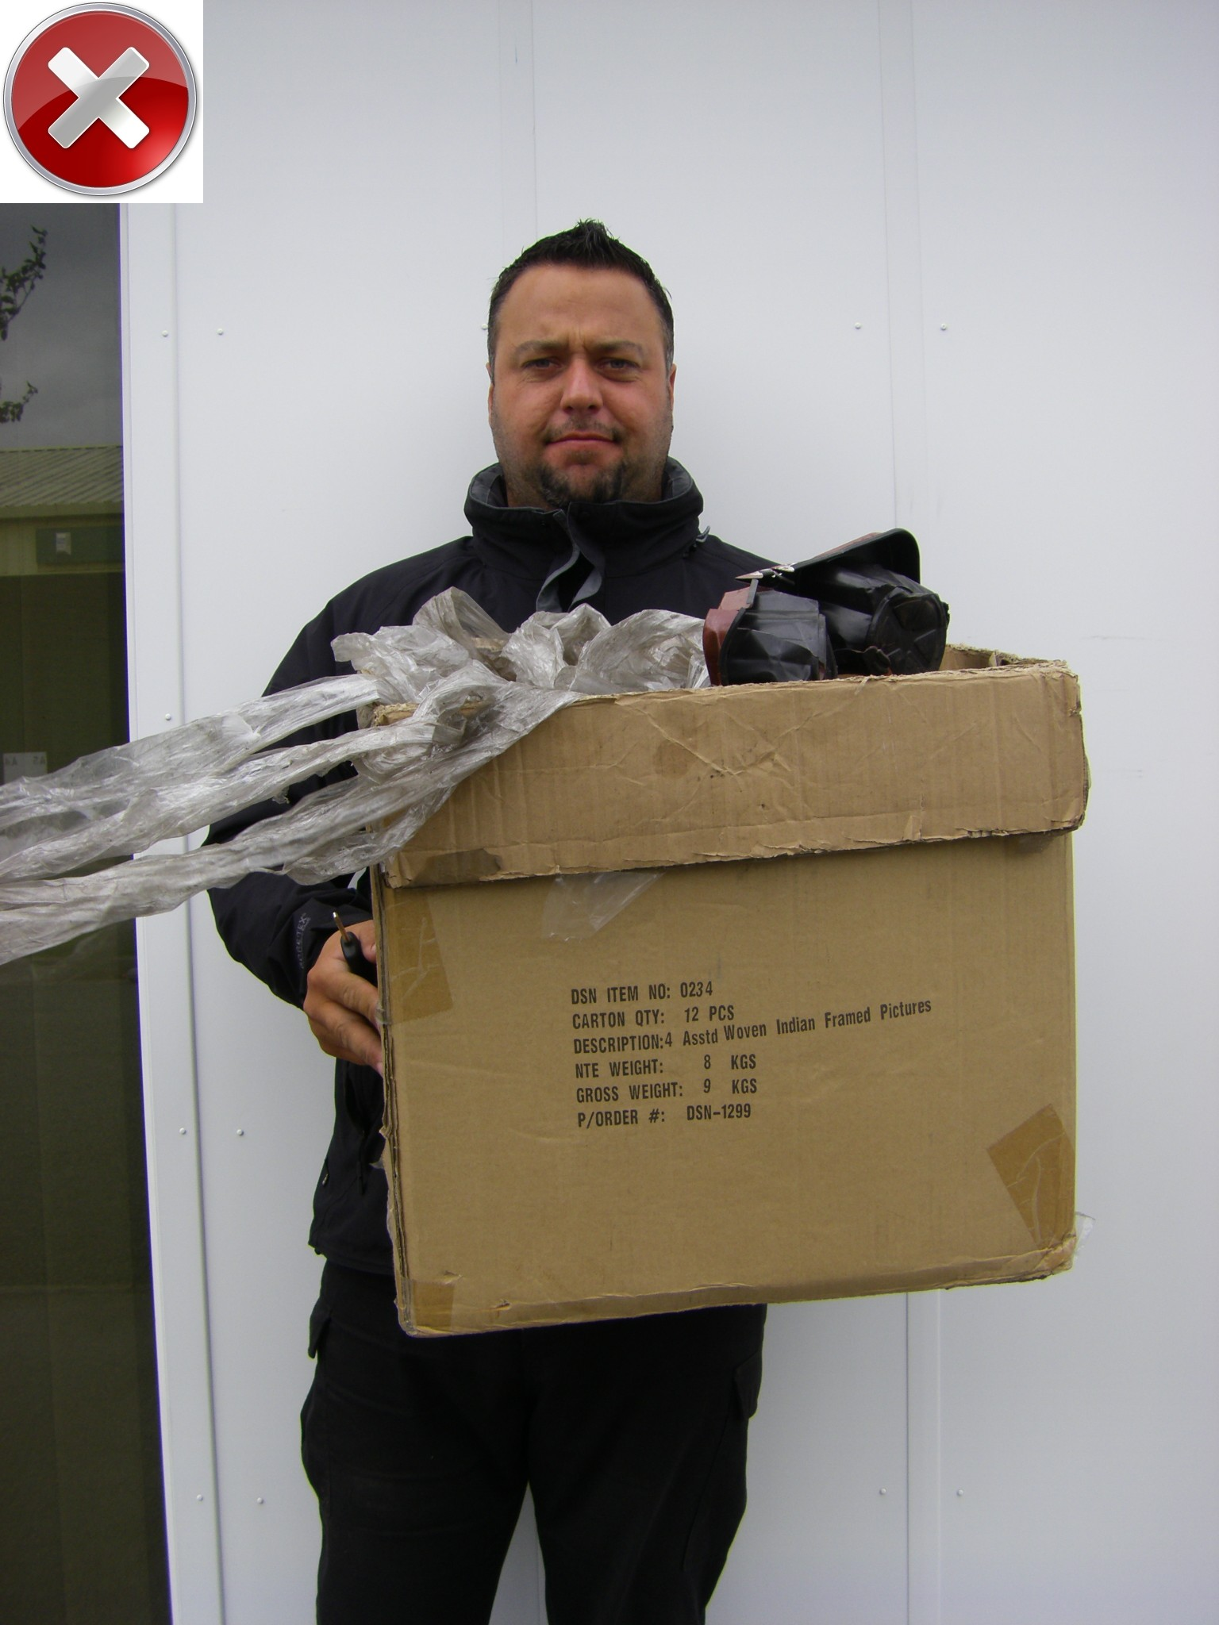
Cardboard Recycling:
You MUST flat pack the cardboard. Put ONLY cardboard in the cardboard container.
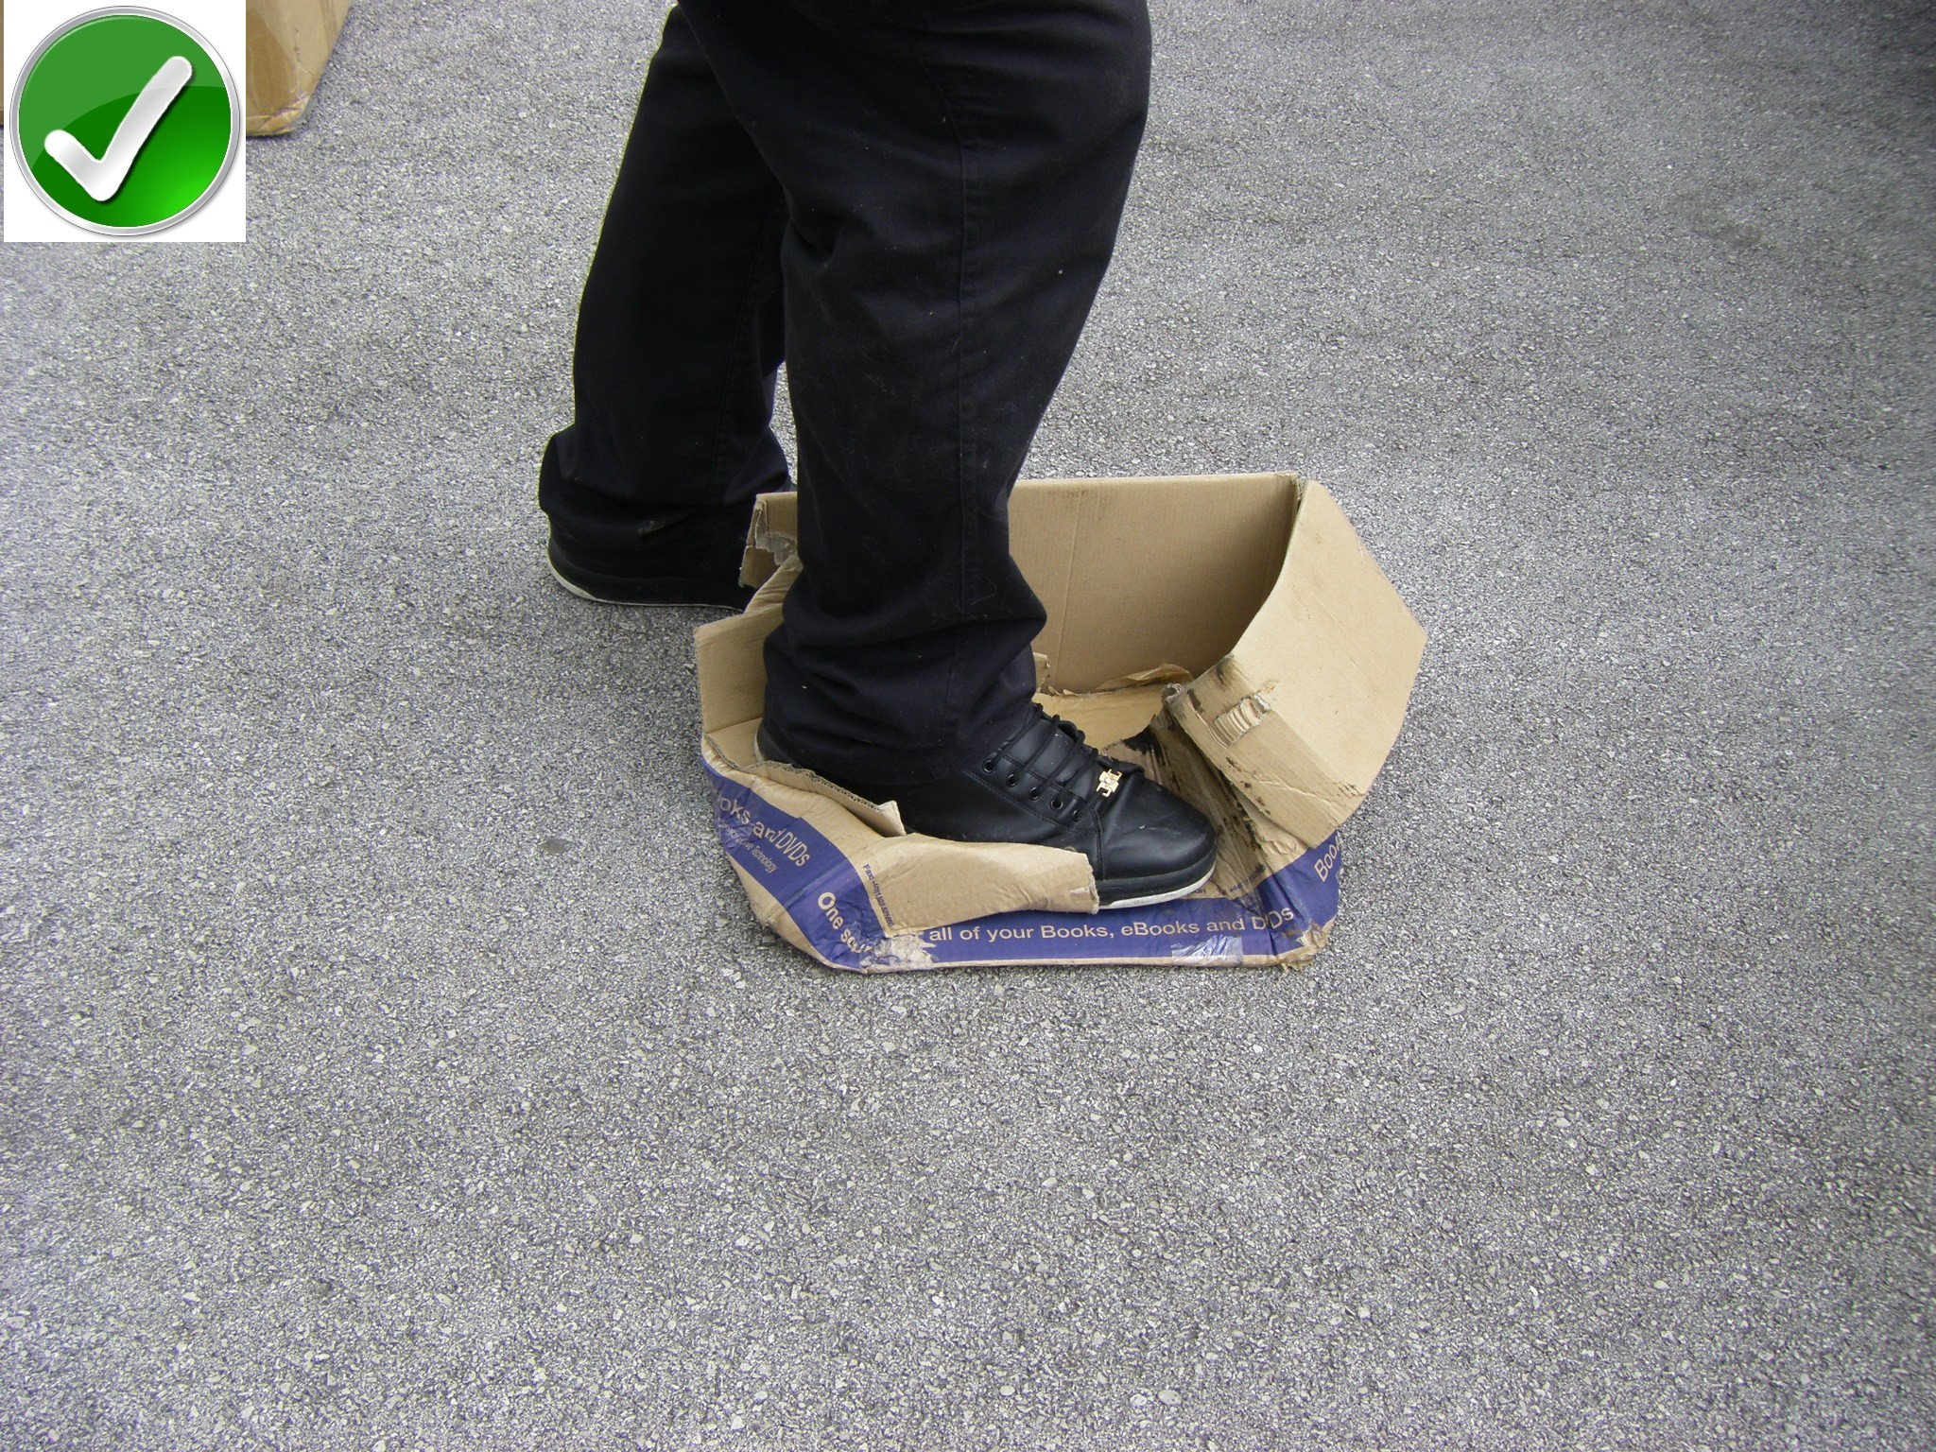 | 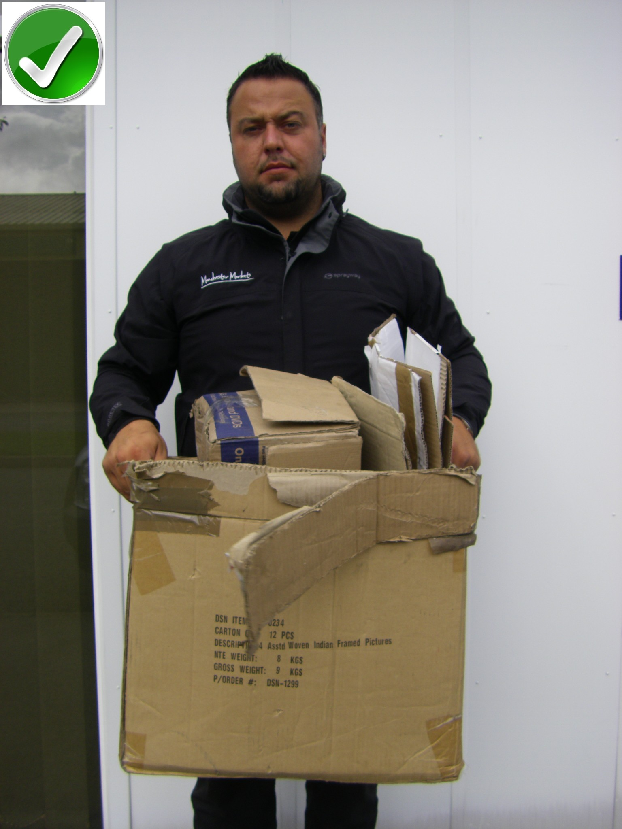
Glass & Plastic Recycling:
All Glass and Plastic Bottles MUST be disposed of in the provided bins. Do not use bags for the disposal. All bottle tops MUST be removed and disposed of within the general refuse.
 | 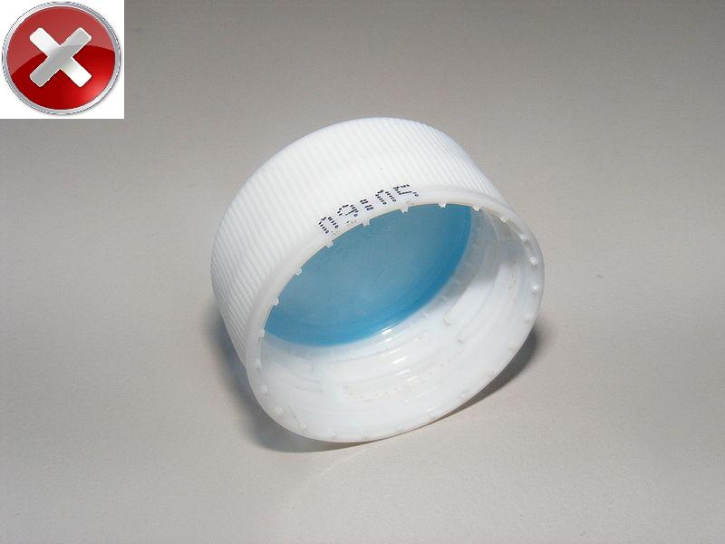

Traders Vehicle ID

Location | ………………………………………………………..
Event: | GÓBÉFEST 2024

Trader Name (PRINT): |  | ………………………………………………………….
Stall Name or T/A: |  | ………………………………………………………….
Mobile Tel: |  | ………………………………………………………….
Vehicle Registration: |  | ................................................................................
Signed |  | Head of Specialist & City Centre Markets  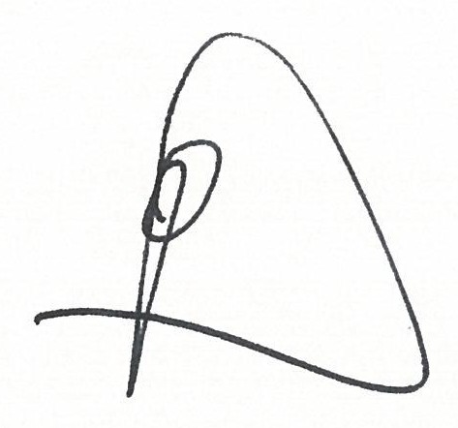
Conditions
1 | This ID must be displayed on the front inside windscreen of the vehicle at all times whilst your vehicle in on the market site.
2 | This form is to identify your vehicle as belonging to one of Manchester Markets traders only.
3 | The form is not a parking permit/ticket and will not allow you any special dispensation if you leave your vehicle in a parking restricted area.
4 | The applicant MUST provide protection to the surface of the square by use of a drip tray or any other substantial protective material to prevent oil droppings
5 | This Permit does not authorise the vehicle to Park on -  1. Taxi Stands/Ranks  2. Loading Bays (without loading/unloading taking place)  3. Pay and Display Bays (without the purchase of a valid Pay & Display ticket)  4. Car Club Bays  5. Double Yellow Lines  6. Single Yellow Lines  7. Any Footpath adjacent to the Highway  8. Bus Stops/Stands.  Any Vehicle parked in Contravention may receive a Penalty Charge Notice and ultimately removed and impounded.

